All Weather Rain Proof Hubless Ebike With Sunroof

E Bikes are the future of 2 wheeler transportation as they are highly economic, work without pollution and without noise. But like all bikes have a major disadvantage that they have an open roof which leaves the rider vulnerable to the rain, heat and pollution.
So here we design a solution to this problem with a covered hubless ebike that introduces an innovative hubless design to the Ebike along with protection from rain, heat and pollution. This makes 2 wheelers much more enjoyable and improves the 2 wheeler transport experience.
For this purpose we design the ebike with dual powered DC motors for high torque generation. Now we use a throttle powered controller and battery system to drive the motor as per user throttle. The bike is now run by a hubless wheel design. The back wheel is driven by 2x DC motors so that enough acceleration torque is generated to drive bike and rider.
The hubless design uses rubber roller shaft attached to the motors to drive the rear wheel. The front wheel is supported by a design that uses 2 sets of free rollers to drive the bike while keeping the wheel in place. The bike body is a mixture of mild steel and aluminium to provide a light weight yet strong frame.
The bike body and seat rest on shock absorbers attached to the wheels. This protects the biker and controller from shocks and vibration to a certain level and improve riding experience. The bike frame now involves a transparent sun protect roof, windshield and side doors to protect rider from sunlight, heat, rain and pollution.
Finally the ebike is equipped with high wattage LED headlights, Taillights, Footrest to make the riding experience enjoyable. Thus our All Weather Rain Proof ebike delivers weather proofing with a hubless ebike experience to take bike riding to the next level.

Components:
- Wheel Rim
- Tyres
- Bike Handle
- Buttons and Switches
- Bike Battery
- Controller
- High Torque DC Motors
- Shafts
- Robber Rollers
- LED For Headlights
- Shock Absorbers
- Brakes
- Rods and Pipes
- Foot Rest Rods
- Shade Glass
- Sheet Metal
- Seat
- Mounts and Joints
- Screws and Bolts
- Cables and Connectors

Advantages:

- All Weather Operation
- Rain Proof | Sun Proof
- Dust Protection
- Direct Pollution Protection
- Zero Pollution Vehicle
- Noise Proof Vehicle
- Low Maintenance

Disadvantages:

- Required Charging
- Has Limited Speed

Block Diagram:

Front View

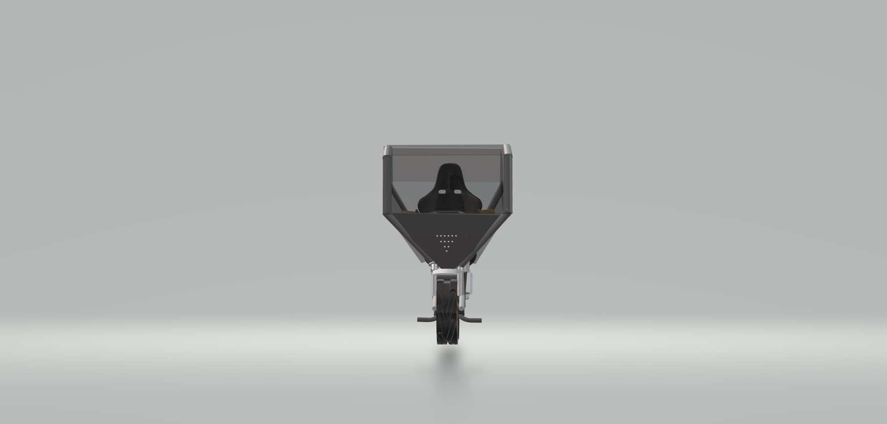

Side View
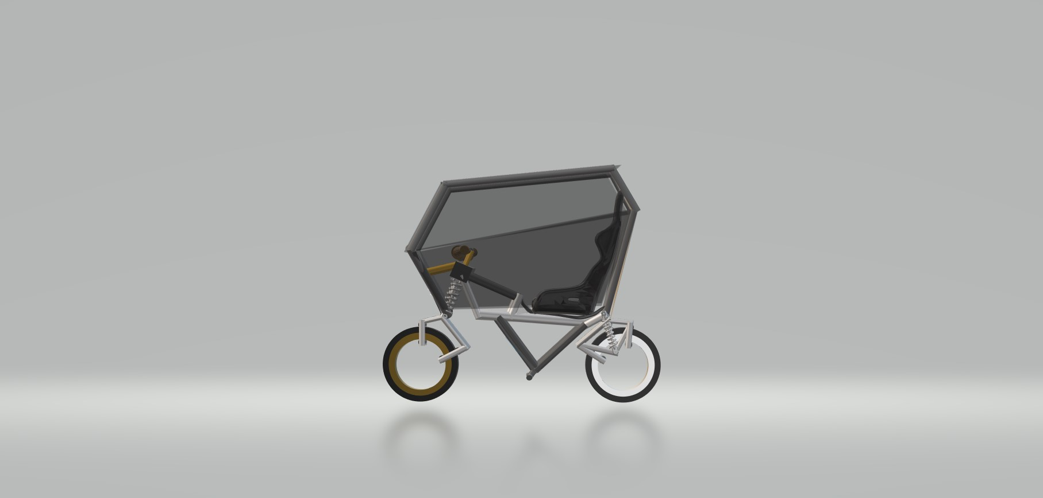

3d Views